Cloud Architecture Pattern

Azure Kubernetes Service

# Introduction

Azure Kubernetes Service (AKS) is a managed Kubernetes service that simplifies the deployment, management, and scaling of containerized applications on Azure. By handling the Kubernetes infrastructure management, AKS allows you to focus on developing your applications.

# Context

* **Fully Managed Kubernetes:** Microsoft manages the control plane, making it easier to deploy and scale.
* **Auto-scaling & Load Balancing:** Automatically adjusts pods and nodes based on demand.
* **Integrated Security & Monitoring:** Works with Azure Monitor, Log Analytics, and Microsoft Sentinel.
* **CI/CD Integration:** Supports Azure DevOps, GitHub Actions, and Jenkins.
* **Multi-cloud & Hybrid Support:** Works with Azure Arc for hybrid deployments.

# Architecture

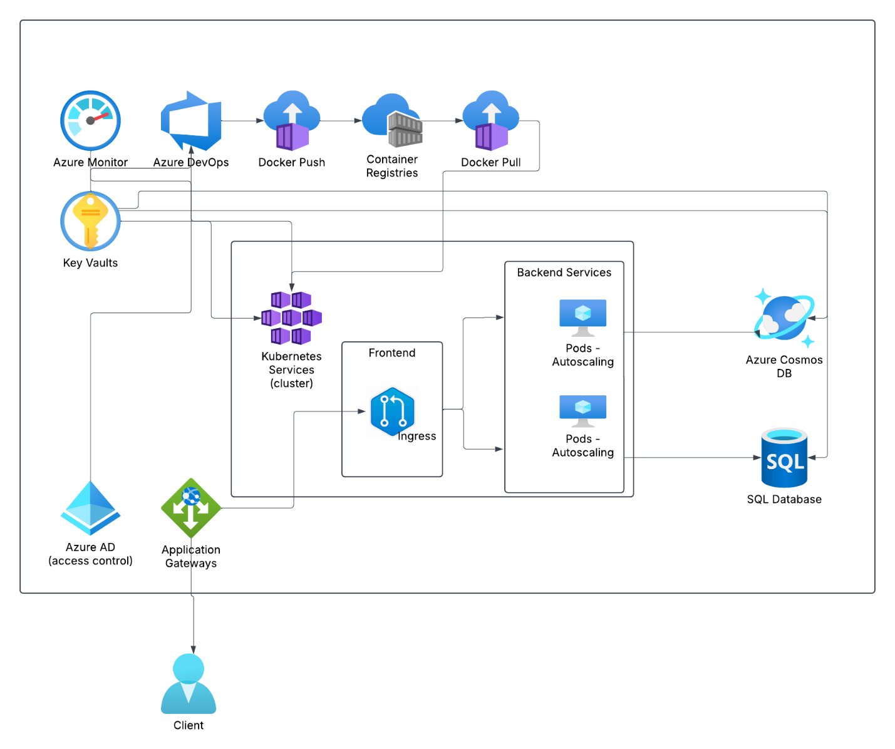

# Design Considerations

When designing and deploying applications on AKS, consider the following:

**Networking Configuration:**

* **Network Topology:** Use a hub-and-spoke network topology to manage traffic efficiently and securely.
* **Ingress Resources:** Deploy ingress controllers to manage external access to your services.

**Cluster Compute:**

* **Node Sizing:** Choose appropriate virtual machine sizes based on your workload requirements.
* **Autoscaling:** Implement cluster autoscaler and horizontal pod autoscaler to handle varying loads.

**Security:**

* **Identity Management:** Integrate with Microsoft Entra ID (formerly Azure AD) for secure access control.
* **Pod Security:** Use Kubernetes security policies to enforce security standards at the pod level.

**Business Continuity:**

* **Disaster Recovery:** Plan for multi-region deployments to ensure high availability and disaster recovery.
* **Backup and Restore:** Implement regular backups of your cluster state and persistent volumes.

**Operations:**

* **Monitoring and Logging:** Use Azure Monitor and Azure Log Analytics to track cluster health and performance.
* **CI/CD Pipelines:** Set up continuous integration and continuous deployment pipelines for automated deployments.

**Cost Management:**

* **Resource Optimization:** Monitor resource usage and optimize to reduce costs.
* **Reporting:** Use Azure Cost Management to track and manage expenses.

# Alternative Container Platforms

1. **Azure Container Instances (ACI):** A serverless container service that allows you to run containers without managing the underlying infrastructure
2. **Amazon EKS (Elastic Kubernetes Service):** A managed Kubernetes service that simplifies deploying, managing, and scaling Kubernetes clusters on AWS. It integrates seamlessly with other AWS services for enhanced functionality and ease of use.
3. **Amazon ECS (Elastic Container Service):** A fully managed container orchestration service by AWS that supports Docker containers and integrates well with other AWS services
4. **Docker Swarm:** A native clustering and orchestration tool for Docker containers. It's simpler to set up and manage compared to Kubernetes
5. **Red Hat OpenShift:** A Kubernetes-based platform with additional features for enterprise applications, including enhanced security and developer tools
6. **HashiCorp Nomad:** A flexible orchestrator that can manage containers, VMs, and other workloads. It's known for its simplicity and scalability
7. **Google Cloud Run:** A serverless platform that runs containers in a fully managed environment, allowing you to focus on writing code without managing infrastructure

Each of these platforms has its own strengths and is suited to different use cases.